ORDER: ORTHOPTERA
(grasshoppers, crickets, and katydids)
with special reference to those found in Utah
prepared by: C. R. Nelson 1998; consulting Edmunds 1986, Hanson 1982.
revised by: D. Jensen 15 Oct 2008

Diagnosing Features, adults:
hind legs modified for jumping (Fig. 1)
3-4 segmented tarsi
biting/chewing mouth parts
shield-like pronotum
winged or wingless
forewings leathery, thickened (tegmina)
hind wings broader and membranous
body elongate
cerci well-developed
ovipositor
tympana

Habitat:
A few Orthoptera are semi-aquatic, found near the edges of water, on emergent aquatic plants, and on or under wet substrates.
Trophic Habits:
Most Orthopterans are defoliators, some are predators and some are decomposers
Development:
paurometabolous
Preservation:
Most can be pinned near posterior margin of the pronotum, some preferred in ethanol
Notes:
Hind wings are folded under tagmina and held over the back of the body.

Figures:
Typical orthopteran
Figure 1.

SUBORDER: CALIFERA (short horned grasshoppers)

FAMILY: ACRIDIDAE (grasshoppers)

Morphology (adults):
antennae shorter than body
tympanum are on the sides of first abdominal segment
3-segmented tarsi
Ecology:
Some are found near water.

FAMILY: TETRIGIDAE (pygmy grasshoppers)

Morphology (adults):
antennae shorter than body
pronotum extends the length abdomen or further over wings
2-segmented tarsi
Ecology:
Some are found near edges of water.
Utah Genera:
Genus 1, Southern Utah
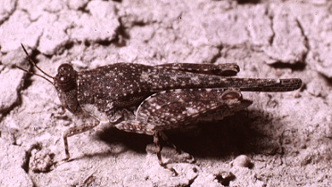
Genus 2
drawing

FAMILY: TRIDACTYLIDAE (pygmy mole grasshoppers)

Morphology (adults):
antennae shorter than body
pronotum not extended posteriorly
front tibia expanded for digging
2-segmented tarsi
Ecology:
Some are found near edges of water.
Utah Genera:
Genus 1, Southern Utah

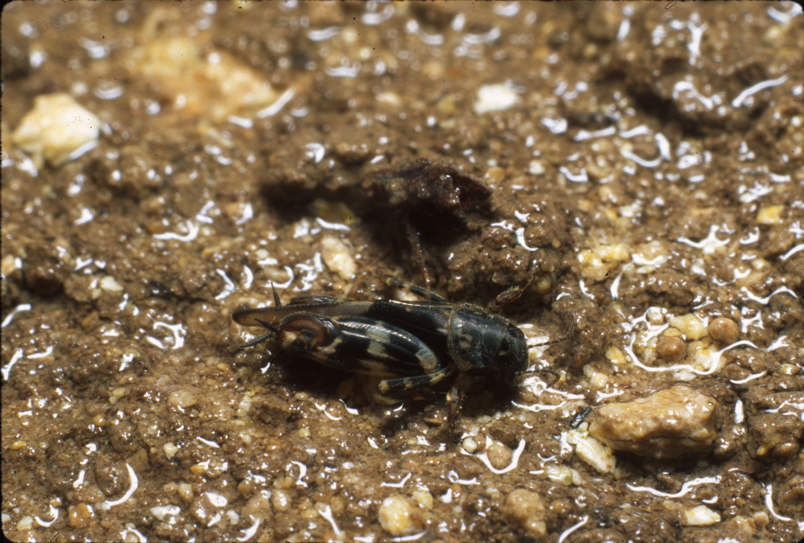

SUBORDER: ENSIFERA (long-horned hoppers)
FAMILY: GRYLLIDAE (crickets)

Morphology (adults):
antennae longer than body
tympanum at base of fore tibia
3-segmented tarsi
right forewing of male generally over left
ovipositor needle-like
Ecology:
Some are found near water. Make musical songs.

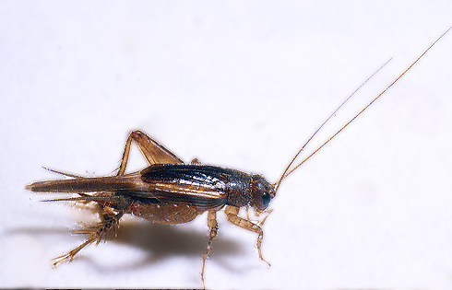

FAMILY: Gryllotalpidae (mole crickets)

Morphology (adults):
body cylindrical
blade-like projections on fore tibia, adapted for digging
hind femur not reaching the tip of abdomen
Ecology:
Some tunnel near water in wet sand or muck. Make buzzing sounds. None reported from Utah.

FAMILY: TETTIGONIIDAE (katydids)

Morphology (adults):
antennae shorter than body
tympanum are on the sides of first abdominal segment
3-segmented tarsi
Ecology:
Some are found near water and on edges. Make rasping sounds.

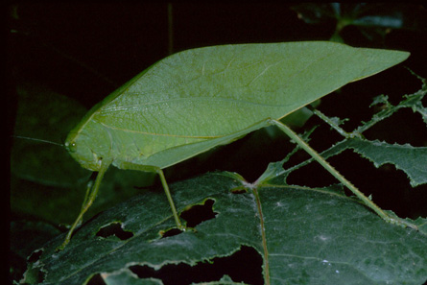

Literature Cited:

Edmunds, G. F., Jr. 1986. An annotated generic check-list of aquatic and semi-aquatic insects of Utah. Univesity of Utah. Unpublished class handout.

Hanson, W. J. 1982. Identification notes for aquatic entomology. Utah State University. Unpublished class handout.

Nelson, C. R. 1998. ORDER: ORTHOPTERA (grasshoppers, crickets, and katydids), with special reference to those found in Texas. Unpublished class handout, University of Texas.

Version: 4 Orthoptera lab sheet 2008 2.doc

