Soil Sampling Protocol for Dissolved Organic Carbon and Dissolved Nitrogen
And Microbial Biomass Carbon and Nitrogen

Items needed: Soil gouge auger (small diameter silver colored)
Large zip-lock storage bags
Sharpie permanent marker
Cooler with ice packs

- Mark gouge auger with a piece of tape at 15cm
- Take 5 soil cores 15 cm deep with the gouge auger and place these into the zip-lock bag
- Label the bag with the site information, the date
- Place the soil sample in the cooler on ice to keep it cool
- Bring the samples back to the lab and store in refrigerator
- Process them within 24 hours

Sample organization and labeling

- Organize the samples by sites and by treatment in alphanumerical order by site number and treatment. This will allow you to reconstruct the order of your samples and easily determine if samples are missing.
- Assign each sample a unique sample ID number – record this number on the data sheet and write it on the bag containing the sample. The sample ID number will be used to label the sample throughout the analysis process.

Soil Processing for Organic Carbon and Nitrogen
Preparing and Extracting Initial Carbon and Nitrogen

Extraction, first filtering, and storage

Items needed: 125 ml Erlenmeyer flasks
50 ml centrifuge tubes
50 ml syringe
Parafilm
Funnels
Whatman filter papers grade 40, 42, or 44 (2.5 to 8 μm)
Nanopure water (or 0.5 M K₂SO₄)

- Tare balance with a 125 mL Erlenmeyer flask
- Label the flask with the sample ID, use permanent marker
- Weigh 25 g (+/-0.5 g) of soil into the flask
- Record the exact mass of the soil on the data sheet
- Weigh an empty soil tin
- Record the tin number (label) and mass on the data sheet
- Weigh 4 g (+/-0.5 g) of soil into a soil tin
- Record the mass of the soil in the tin on the datasheet
- Dispense 50 mL of Nanopure water into the flask (1:2 weight to volume ratio)
- Also include two blanks in the analysis to control for C and N from filtering
- Cover the flask with parafilm
- Shake for 60 minutes on shaker at low speed (100 - 150 rpm)
- Use funnels and Whatman filter paper (grade 40, 12.5 cm diameter)
- Place the filters in the funnels above the labeled centrifuge tubes (label tubes with the experiment name, “C” for organic carbon, the date, and the Sample ID). Use permanent marker to label the tubes.
- Pour the supernatant into the filter and let stand for approximately 8 hours until the liquid has filtered through to the centrifuge tube
- Cap the centrifuge tubes and place them in the freezer
- Store samples at -20 C until they are ready for the second filtering and analysis
- Place the soil tins into the drying oven for 48 hours on low
- Reweigh the tins and record their dry mass on the data sheet
- Wash the dishes using soap or acid bath, rinse three times with regular water and three times with DI water, final rinse with nanopure water if the dishes will be used in the analysis again
- Use acetone to remove the marker (use ventilation hoods while working with acetone)

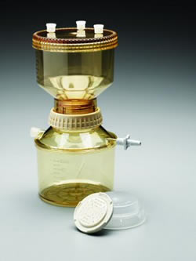
Second filtering and analysis of samples

Items needed: Vacuum filter cups
Whatman membrane filters NL 17, 0.45 μm
50 mL centrifuge tubes rinsed with nanopure water
1.5 M HCl
Disposable pipette
pH meter

- Take the samples out of the freezer and put them into the fridge approximately 3 days prior to filtering. It will take time for the samples to thaw.
- When the samples have thawed, pour the supernatant into the vacuum filter cups
Vacuum filter cup
- Filter the supernatant using Whatman NL 17 Membrane filters (Polyamide), 0.45 μm, 47 mm diameter
- Pore the filtrate into a labeled centrifuge tube
- Check the pH
- Use the disposable pipette to add 1 drop of 1.5 M HCl
- Stir the solution with the pH meter, the pH should now be approximately 2.5
- Place the samples in the refrigerator until they are ready to be run on the Shimadzu TOC-L Total Organic Carbon Analyzer (Rachel Buck has protocols for the TOC-L instrument)

Applying Proportional Correction for Drift during Analysis

Step 1: Calculate the proportional drift in the measured concentrations of the reference standards with known concentrations

Equation 1: Proportional drift = (Measured Concentration – Standard Value) / Standard Value

Example 1: If the measured concentration is 21.56 ppm and the reference standard value is 25 ppm, then the equation for the proportional drift is (21.56 - 25) / 25 = -0.1376.

Step 2: Assign each measurement an injection number for the run starting with the first sample in the run.

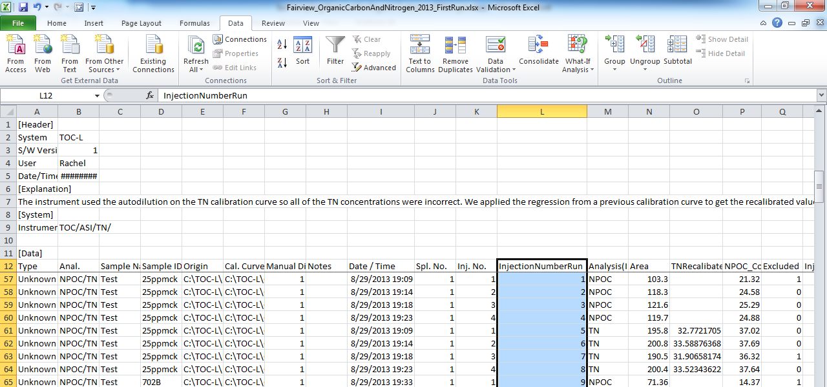

Step 3: Calculate the linear regression of the proportional drift over the run. (x = Injection Number for the Run, y = Proportional drift)

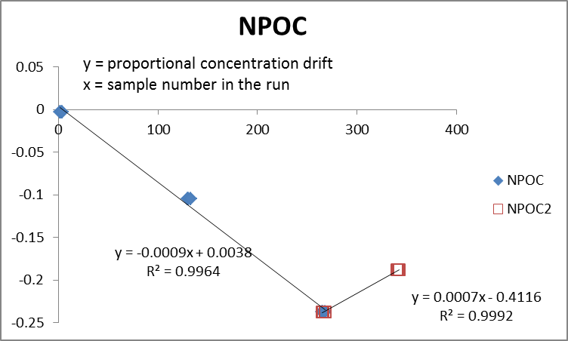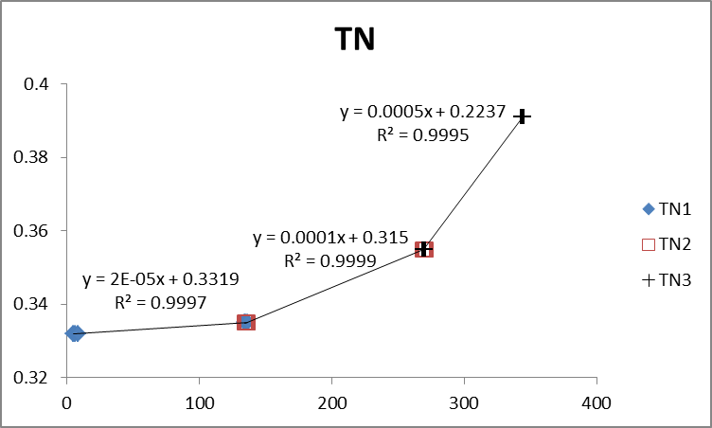

Step 4: Calculate the proportional drift for each sample in the run based on the linear regression equation(s).

Equation 2: Proportional drift_sample = Injection Run Number * Slope + Intercept

Step 5: Calculate the amount of drift for each sample.

Equation 3: Drift = Proportional drift * Measured Concentration

Step 5: Adjust the measured concentrations of samples by adding the drift

Equation 4: Drift-Adjusted Concentration = Measured Concentration - Drift

Step 6: Calculate the new mean concentration from the average of the Drift-Adjusted concentrations, exclude the injections that were excluded in the original analysis.

This can easily be accomplished by filtering out the excluded values copying the data to a new worksheet and then using a pivot table to get the mean values for each sample number.

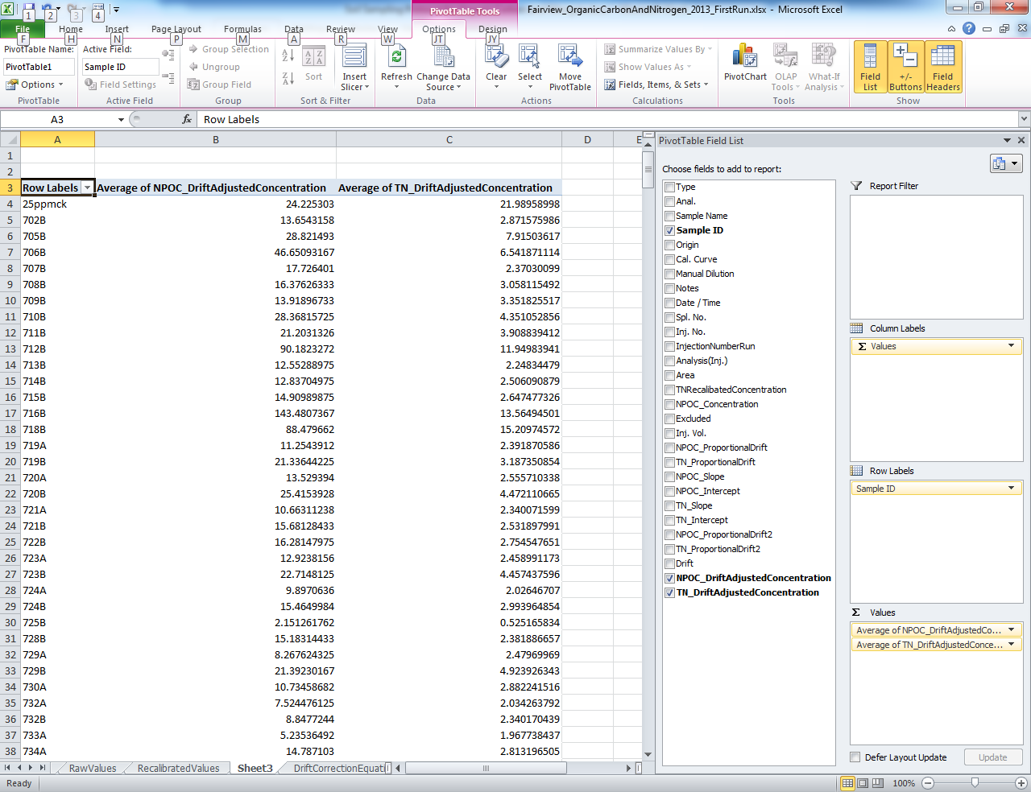

Calculating Microbial Biomass Carbon and Nitrogen

Step 1: Calculate the concentration of C and N in the soil.

Step 1.a: Calculate the dilution factor of dry weight of soil to the volume of the extractant. The dilution factor is the total mass of the solution divided by the initial mass of the soil.

Example: If the soil dry weight is 21 g and you added 50 mL then the dilution factor is (21 grams + 50 mL) / 21 grams = 3.38.

Step 2: Convert ppm C and N to μmol C / g dry soil.

Step 2.a: To convert ppm to μmol / g divide the concentration in ppm by the molar mass of the element or compound (C = 12.0107 g / mole; N = 14.0067 g / mole).

Step 3: Subtract the initial C and N concentrations from the fumigated C and N concentrations.

Initial values for organic carbon and nitrogen refer to the samples that are not fumigated.
All glassware and centrifuge tubes should be rinsed with nanopure water and air dried.
To make 0.5 M K₂SO₄ dissolve 87.13 g K₂SO₄ in 1 L Nanopure water
The TOC-L instrument takes 3 to 5 injections per sample but only uses the 3 most similar injections to calculate the average concentration.

